|  |  |  |  |  |  |  |  |  |  |
| --- | --- | --- | --- | --- | --- | --- | --- | --- | --- |
| **SCHOOL OF COMPUTER SCIENCE AND ARTIFICIAL INTELLIGENCE** | | | | | **DEPARTMENT OF COMPUTER SCIENCE ENGINEERING** | | | | |
| **ProgramName:**B. Tech | | | | **Assignment Type: Lab** | | | **AcademicYear:**2025-2026 | | |
| **CourseCoordinatorName** | | | | Venkataramana Veeramsetty | | | | | |
| **Instructor(s)Name** | | | | |  | | --- | | Dr. V. Venkataramana (Co-ordinator) | | Dr. T. Sampath Kumar | | Dr. Pramoda Patro | | Dr. Brij Kishor Tiwari | | Dr.J.Ravichander | | Dr. Mohammand Ali Shaik | | Dr. Anirodh Kumar | | Mr. S.Naresh Kumar | | Dr. RAJESH VELPULA | | Mr. Kundhan Kumar | | Ms. Ch.Rajitha | | Mr. M Prakash | | Mr. B.Raju | | Intern 1 (Dharma teja) | | Intern 2 (Sai Prasad) | | Intern 3 (Sowmya) | | NS_2 ( Mounika) | | | | | | |
| **CourseCode** | | | 24CS002PC215 | **CourseTitle** | | AI Assisted Coding | | | |
| **Year/Sem** | | | II/I | **Regulation** | | R24 | | | |
| **Date and Day**  **of Assignment** | | | Week2 - Wednesday | **Time(s)** | |  | | | |
| **Duration** | | | 2 Hours | **Applicableto**  **Batches** | |  | | | |
| **AssignmentNumber:4.3**(Present assignment number)/**24**(Total number of assignments) | | | | | | | | | |
|  | | | | | | | | | |
|  | **Q.No.** | **Question** | | | | | | ***ExpectedTime***  ***to complete*** |  |
|  | 1 | Lab 4: Advanced Prompt Engineering – Zero-shot, One-shot, and Few-shot Techniques  **Lab Objectives:**   * To explore and apply different levels of prompt examples in AI-assisted code generation. * To understand how zero-shot, one-shot, and few-shot prompting affect AI output quality. * To evaluate the impact of context richness and example quantity on AI performance. * To build awareness of prompt strategy effectiveness for different problem types.   **Lab Outcomes (LOs):**  After completing this lab, students will be able to:   * Use zero-shot prompting to instruct AI with minimal context. * Use one-shot prompting with a single example to guide AI code generation. * Apply few-shot prompting using multiple examples to improve AI responses. * Compare AI outputs across the three prompting strategies.   **Task Description#1**   * Zero-shot: Prompt AI to write a function that checks whether a given year is a leap year.   **Expected Output#1**   * AI-generated function with no examples provided   **Task Description#2**   * One-shot: Give one input-output example to guide AI in writing a function that converts centimeters to inches.   **Expected Output#2**   * Function with correct conversion logic   **Task Description#3**   * Few-shot: Provide 2–3 examples to generate a function that formats full names as “Last, First”.   **Expected Output#3**   * Well-structured function respecting the examples   **Task Description#4**   * Compare zero-shot and few-shot prompts for writing a function that counts the number of vowels in a string.   **Expected Output#4**   * Functional output and comparative reflection   **Task Description#5**   * Use few-shot prompting to generate a function that reads a .txt file and returns the number of lines.   **Expected Output#5**   * Working file-processing function with AI-guided logic   **Note: Report should be submitted a word document for all tasks in a single document with prompts, comments & code explanation, and output and if required, screenshots**  **Evaluation Criteria:**   | **Criteria** | **Max Marks** | | --- | --- | | Zero Shot (Task #1) | 0.5 | | One Shot (Task#2) | 0.5 | | Few Shot (Task#3 & Task #5) | 1.0 | | Comparison (Task#4) | 0.5 | | **Total** | **2.5 Marks** | | | | | | | Week2 - Wednesday |  |

**Task Description#1**

* Zero-shot: Prompt AI to write a function that checks whether a given year is a leap year.

**Expected Output#1**

* AI-generated function with no examples provided

Prompt : Write a python program to check whether the given year is leap year or not

Github:

Cursor:

**Task Description#2**

* One-shot: Give one input-output example to guide AI in writing a function that converts centimeters to inches.

**Expected Output#2**

* Function with correct conversion logic

Prompt : Write a python function that converts centimeters to inches ? example if 10 cm = 3.94 inches and print the output

GitHub:

Cursor :

**Task Description#3**

* Few-shot: Provide 2–3 examples to generate a function that formats full names as “Last, First”.

**Expected Output#3**

* Well-structured function respecting the examples

Prompt : Write a python function where you need to enter the full name of the person and it should print the output as swap the first name to last name and last name to first name. For example : Sai Kumar output: Kumar Sai Test2: Maneesha Rallabandi output :Rallabandi Maneesha Test 3: Shari Punnisa output:Punnisa Shari.Take dynamic input

GitHub:

Cursor:

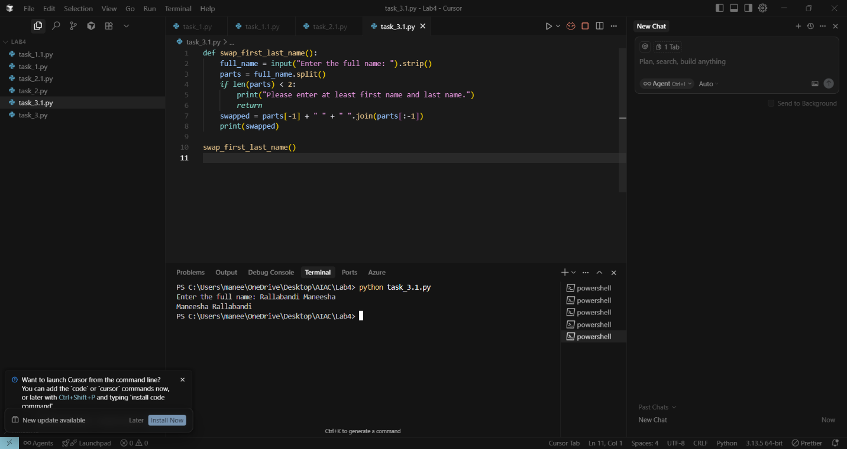

**Task Description#4**

* Compare zero-shot and few-shot prompts for writing a function that counts the number of vowels in a string.

**Expected Output#4**

* Functional output and comparative reflection

Prompt for Zero-shot : Write a python function to count the no of vowles in a given string and print the output use dynamic input

GitHub:

Cursor :

Prompt for few shot :Write a python function to count the no of vowels in a dynamic string and print the output . example test1 apple output:2 test2 egg output : 1 test3 : banana output : 3.Take a dynamic input

GitHub:

Cursor :

**Task Description#5**

* Use few-shot prompting to generate a function that reads a .txt file and returns the number of lines.

**Expected Output#5**

Working file-processing function with AI-guided logic

Prompt : Write a python function that reads lab4.txt file and it should returns the number of lines present in that file and print the output .example

*The sun dipped low, painting the sky in hues of fire and gold.*

*She walked in silence, each step echoing memories long forgotten. Out put : No.of lines : 2*

*Test 2: Beneath the stars so vast and high,  
The whispers of the night drift by.  
A gentle breeze, a silent tune,  
That dances with the silver moon.*

*Out put : 4 lines*

GitHub:

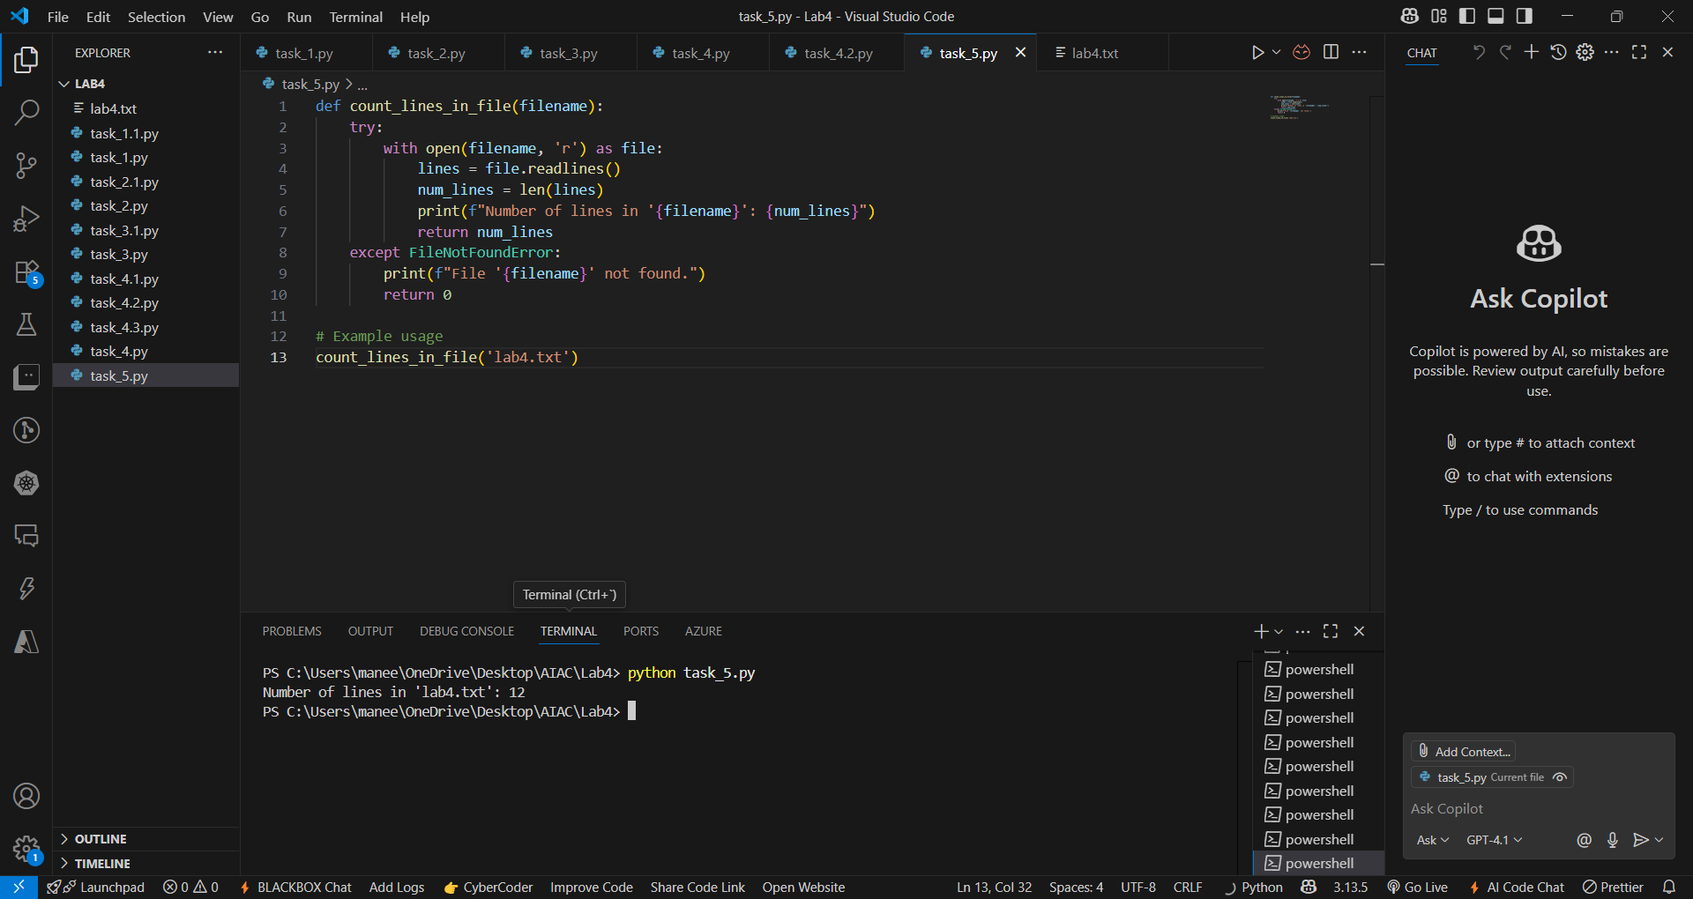

Cursor:

